THE LAST OBSERVATIONS OF THE LONG-SPINED EXOTIC SEA URCHIN (Diadema setosum) IN THE GULF OF ANTALYA
Mehmet Gökoğlu¹ Ferhat Çağıltay² Mustafa Gürdal³ Alper Yıldız¹
¹Akdeniz University, Faculty of Fisheries, Antalya-Türkiye
²İstanbul University, Faculty of Aquatic Sciences, İstanbul-Türkiye
Correspondence: gokoglu@akdeniz.edu.tr, fax: +902422262013

Abstact
Diadema setosum, a Red Sea migrant, was first identified on the shores of the Kaş Peninsula in the Mediterranean. Approximately a year after this observation, the same species was reported for the second time from Konyaaltı Beach in Antalya Bay. This sea urchin rapidly multiplied and expanded its distribution along the coasts of the Mediterranean and Aegean Seas, reaching as far as the Marmara Sea. Some individuals of this sea urchin, which expanded distribution to coastal areas posing a risk to swimmers, were observed to start dying in the summer months of 2022. Scuba diving surveys were conducted in five different areas with rocky and stony seabed structures in the Gulf of Antalya during the winter season (Cliffs, Konyaaltı Beach, Sıçan Island surroundings, Çaltıcak region, and Kemer Ağva Cape), and it was determined that 99% of the D. setosum population had died in February and March. No living individuals were encountered during scuba diving surveys conducted in the same stations in April and May.
In conclusion; mass mortalities have occurred in the D. setosum population in the rocky areas of the Gulf of Antalya, including the cliffs, Konyaaltı beach, Sıçan island surroundings, Caltıcak region, and Kemer Ağva Cape. This study presents the first report on matter.
Keywords: Diadema setosum, Gulf of Antalya, Sea urchin

- Introductıon
The Mediterranean Sea is connected to the Atlantic Ocean in the west naturally, and to the Red Sea through the man-made Suez Canal in the east. After the opening of the Suez Canal, many tropical organisms originating from the Red Sea migrated and settled in the Mediterranean. One of these migrating organisms is the long-spined sea urchin Diadema setosum. The first record of this echinoderm species in the Mediterranean was made by Yokeş and Galil (2006) along the coast of the Kas Peninsula. Approximately a year after this record, Gökoğlu et al. (2007) reported a second record of D. setosum from Antalya, Konyaaltı Beach at a depth of 5-6 meters. Later, in 2009, it was observed in the coastal waters of Monsef town along the Lebanese coast (Nader & El Indary 2011), and in 2010, it was observed in the Gulf of Iskenderun, Yayladağı, on the southeastern coast of Turkey (Turan et al. 2011). After these reports, D. setosum rapidly proliferated in the Mediterranean and expanded its distribution along the coasts of Turkey, Greece, Lebanon, Israel, Egypt, and Libya (Zirler et al., 2023). D. setosum, which can be observed up to a depth of 2-3 meters in rocky and stony areas with wave action, has also started to pose a risk for local people.
Diadema setosum is a species of sea urchin belonging to the Diadematidae family. Its long spines are hollow and contain a mild venom. D. setosum differs from other Diadema species by having five characteristic white spots on its body. Additionally, a distinctive feature of this species is the presence of a bright orange anal sac around the periproctal cone of the sea urchin (Yokeş and Galil, 2006).
D. setosum, a species of sea urchin, is distributed in the Indian-Pacific regions from Australia and Africa to Japan and the Red Sea. The spines of this sea urchin can cause painful stings when stepped on, as they are poisonous. Although the toxin is not a deadly threat to humans, it mostly causes swelling and pain. Its long spines are easily broken and enable it to move very quickly.
Mass mortality in sea urchins is a common occurrence. The best example of this can be demonstrated by the collapse of the Diadema antillarum population in the Caribbean and Western Atlantic. In the Caribbean, the sea urchin D. antillarum, which almost disappeared the early 1980s due to an unknown reason, experienced a similar mass mortality event again in 2022 (Hewson et al., 2023). These mass mortalities are reported to be caused by a pathogen. Similarly, mass mortality events were observed in Diadema africanum populations in the Eastern Atlantic in 2009 (Zirler et al., 2023). It is reported that Vibrio alginolyticus, which increases due to abnormally rising water temperatures, is responsible for these mortalities (Clemente et al., 2020).
During the summer months (in 2022), while we were scuba diving in the Gulf of Antalya, we encountered some deceased individuals of D. setosum and found shells and spines belonging to them. Initially, it was thought that the shells and spines belonged to sea urchins that had been consumed by fish or other organisms. However, after the winter season, mass deaths were observed among D. setosum individuals in the Gulf of Antalya. The aim of this study is to determine the current status of D. setosum in the Gulf of Antalya.

- Materials and methods
This research was conducted between September 2022 and June 2023 in five different areas of the Gulf of Antalya with rocky and stony seabed structures (Cliffs, Konyaaltı Beach, Sıçan Island surroundings, Çaltıcak region, and Kemer Ağva Cape) (Figure 1). The research was carried out through 50 scuba dives between depths of 2-30 m, and we used scuba tanks filled with 15 liters of air at 200 bars in our studies. For underwater photography, we used a Canon G12 camera and a housing. Dives in the research areas were conducted with 2, 4, and 6 individuals, following zigzag patterns. While some dives were from the shore, but some boats was used for dives around Sıçan Island (9m fishing boat) and in the Kemer region (diving boat belonging to Octopus Diving Centre).
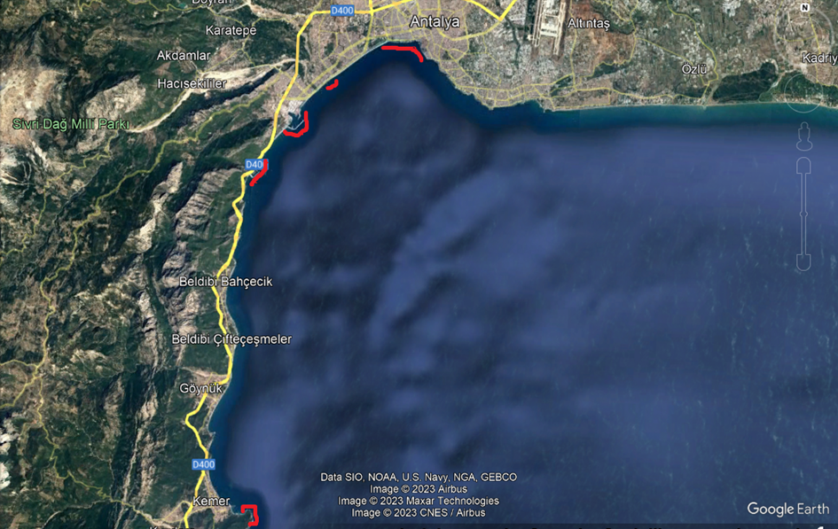
Figure 1: Areas (highlighted in red) where the presence of D. setosum is being investigated in the Gulf of Antalya.

3. Discussion
D. setosum, a Red Sea migrant, has rapidly expanded its distribution along the Mediterranean and Aegean coasts of Turkey since its first record in 2006. One of the most densely populated areas of this species in the Mediterranean is the rocky shores of the Gulf of Antalya (Çağıltay et al. 2022).
The diving courses of Akdeniz University students is generally conducted in Antalya Cliffs, Konyaaltı Beach, Sıçan Island, Çaltıcak Region, and Kemer Ağva Cape areas. Due to the excessive proliferation of D. setosum and the toxicity of its spines, sea urchins are observed and contact with them is avoided during these dives conducted throughout the year. During diving activities carried out in the summer months of 2022, it was observed that some individuals of D. setosum died. Initially, it was thought that these deaths were caused by fish or other organisms that consume sea urchins as food. Meanwhile, monthly samplings were conducted for a TUBITAK project related to D. setosum. It was observed during scuba dives conducted for these purposes that there was an increase in D. setosum mortality in the autumn months. These deaths continued to increase during the winter season, and meanwhile, a strong storm occurred in the Gulf of Antalya on January 27 - 28, 2023. Following this storm, during our scuba dives conducted in February and March, it was determined that 98-99% of the D. setosum population at diving and sampling stations had died. In all the areas where we dived, it was observed that the surviving sea urchins either shed their spines or had a decrease in their ability to move.
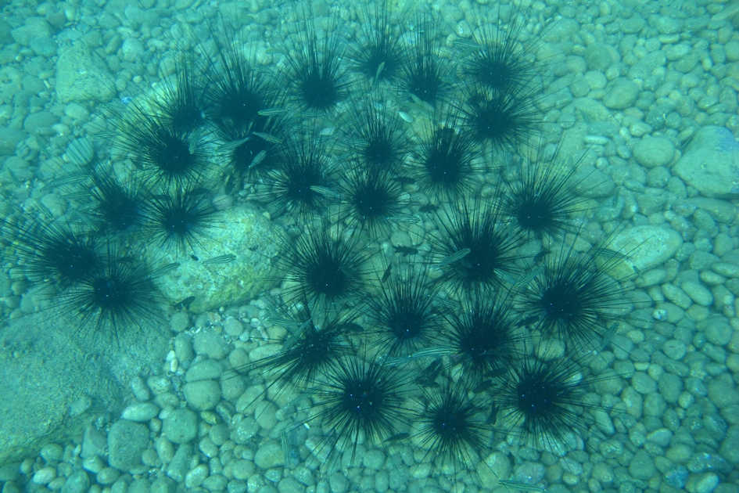
Figure 2: Density of D. setosum on the rocky and pebbly surface of Konyaaltı Beach (summer season of 2022).
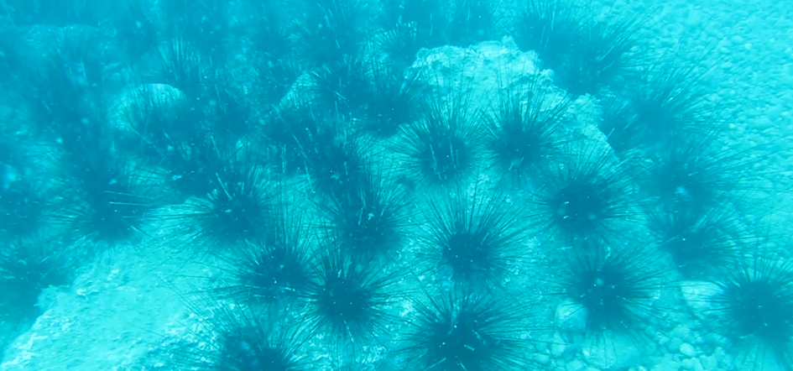
Figure 3: Density of D. setosum in a rocky area during the summer season of 2022
In our divings in April-May, which are still ongoing in 2023, no live individuals of D. setosum could be found, but the spines and shells of dead individuals were encountered (Figure 4-5).
Mass mortality incidents can occur on sea urchins. The best example of this is the collapse of the Diadema antillarum population in the Caribbean and Western Atlantic, as found in our literature research (Hewson et al. 2023; Zirler et al. 2023). It has been reported that this species experienced recurring mass mortalities in the 1980s and 2022. Similarly, a similar situation was observed in a related species, Diadema africanum, in the Eastern Atlantic in 2009, where 65% of the population was lost, and in the Canary Islands in 2018, where 93% of the population was lost (Hernandez et al. 2020: Sangil and Hernandez 2022). The cause of death was identified as Vibrio alginolyticus in the study. A similar mass mortality event also occurred on the Pacific coast of Mexico, affecting Diadema mexicanum, which is one of the endemic species of this region (Benítez-Villalobos et al. 2009).
A similar mass death incidents is also occurring with D. setosum, a Red Sea migrant. In the different regions of the Gulf of Antalya (Cliffs, Konyaalti Beach, Sican island regions, Calticak region, and Kemer Agva Cape), mass mortalities have been observed in the stations we determined, and no living D. setosum individuals have been encountered. In discussions with diving tourism centers in the region, it has been reported that these mortalities are also observed in Ucadalar, Beldibi, and Goynuk regions. Although these mass deaths in a foreign and invasive species may seem positive in a way, the pathogens causing them can also be a threat to native sea urchin species in the Mediterranean.
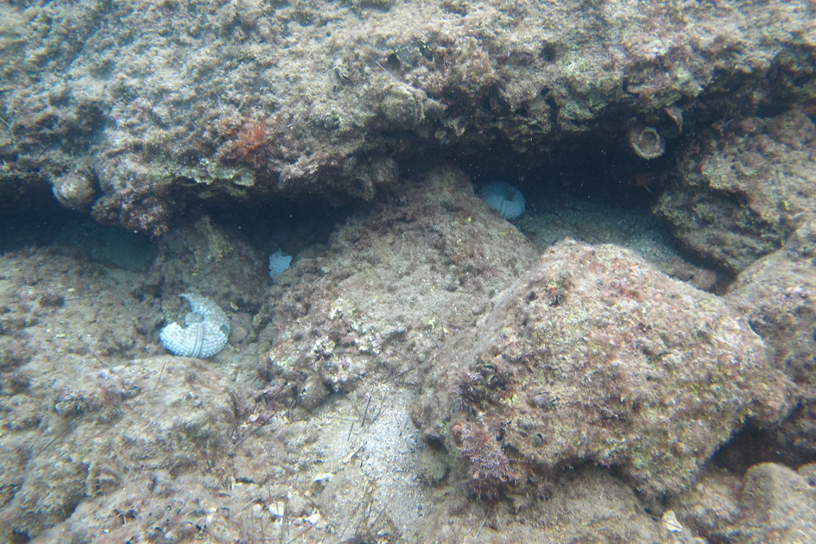
Figure 4: Shells of D. setosum found around rocks of Sican Island.
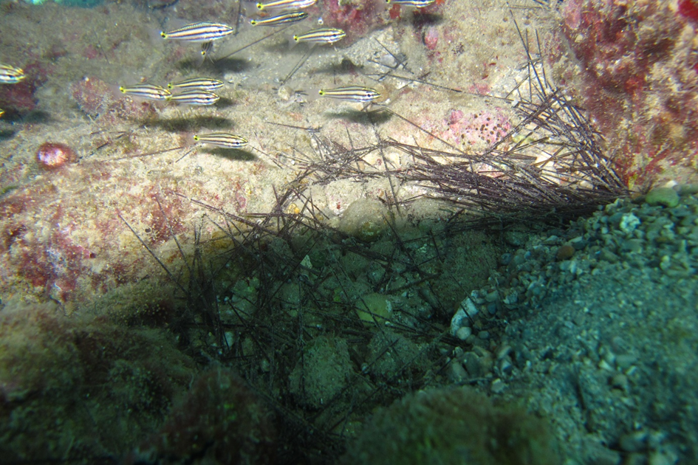
Figure 5: Spines belonging to D. setosum, which had died on Sıcan Island.

- Conclusion
In conclusion, this study provides information about the current status of D. setosum in the Gulf of Antalya. This is highly important in terms of whether the species will be able to regenerate its population in the future.

References
Benítez-Villalobos F, Díaz Martínez JP, Martínez-García M. 2009 Mass mortality of the sea urchin Diadema mexicanum in La Entrega at Bahias de Huatulco, Western Mexico. Coral Reefs 28, 1017. (doi:10.1007/s00338-009-0541-5)
Clemente, S., Lorenzo-Morales, J., Mendoza, JC., López, C., Sangil, C., Alves, F., Kaufmann, M., Hernández, JC., 2014. Sea urchin Diadema africanum mass mortality in the subtropical eastern Atlantic: role of waterborne bacteria in a warming ocean. Mar. Ecol. Prog. Ser. 506, 1–14. (doi:10.3354/meps10829)
Cagiltay, F., Gokoglu, M., Yilmaz, R., and Yildiz, A., (2022). Some Fish Species Showing Commensalism Traits With Long-spined Sea Urchin (Diadema setosum Leske, 1778) in Gulf of Antalya Ind.Fish.Res.J. Vol. 28 No. 1. 33-39 DOI: http://dx.doi.org/10.15578/ifrj.28.1.2022.%25p

Hernández JC, Sangil C, Lorenzo-Morales J. 2020 Uncommon southwest swells trigger sea urchin disease outbreaks in Eastern Atlantic archipelagos. Ecol. Evol. 10, 7963–7970. (doi:10. 1002/ece3.6260)
Hewson, I., et al. 2023. A scuticociliate causes mass mortality of Diadema antillarum in the Caribbean Sea. Sci. Adv. 9, eadg3200. (doi:10. 1126/sciadv.adg3200)
Gökoğlu, M., Balcı, BA., Çolak, H., Banbul Acar, BA., 2007. Akdeniz’de Uzun Dikenli Deniz Kestanesi’nin (Diadema setosum; Leske 1778) ikinci Kaydı. SBT 2007, 11, Underwater Science and Technology Meeting, Istanbul.
Nader, MR., Indary SI., 2011. First record of Diadema setosum (Leske, 1778) (Echinodermata, Echinoidea, Diadematidae) from Lebanon, Eastern Mediterranean. Aquat. Invas. 6: S23−S25
Sangil C, Hernández JC. 2022 Recurrent largescale sea urchin mass mortality and the establishment of a long-lasting alternative macroalgae-dominated community state. Limnol. Oceanogr. 67, S430–S443. (doi:10.1002/lno.11966)
Turan, C., Erguden, D., Uygur, N., 2011. On the occurrence of Diadema setosum (Leske, 1778) in Antakya Bay, Eastern Mediterranean Sea. J Black Sea/Mediterr Environ 17: 78−82
Yokes, B., Galil, BS., 2006. The first record of the needle-spined urchin Diadema setosum (Leske, 1778) (Echinodermata: Echinoidea: Diadematidae) from the Mediterranean Sea. Aquat. Invasions 1, 188–190. (doi:10.3391/ai. 2006.1.3.15
Zirler, R., Schmidt, L-M., Roth, L., Corsini-Foka, M., Kalaentzis, K., Kondylatos, G., Mavrouleas, D., Bardanis, E., Bronstein, O., 2023. Mass mortality of the invasive alien echinoid Diadema setosum (Echinoidea: Diadematidae) in the Mediterranean Sea. R. Soc. Open Sci. 10: 230251. https://doi.org/10.1098/rsos.230251

